**Site Plan**

**Overview**

**Name**

Bountiful Foods

**Purpose**

The purpose of this website is to attract the young people to buy our products.

**Domain name**

The domain name for this website will be: [bountifulfoods.com](http://bountifulfoods.com/)

**Branding**

**Website Logo**



### Color Palette

Palette URL: <https://coolors.co/e40000-271f30-6f8695-7fefbd-c9cba3>

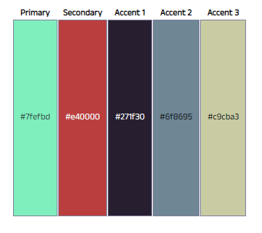

### Site Map

### 

### Audience

Our audience are university and high-school students that are close to the business area, in the high-end market.

|  |  |
| --- | --- |
| Persona | University student |
| Photo |  |
| Fictional Name | Jake Smith |
| Finance Student | N/A |
| Demographics | * 23 years old * Single * He is in his last semester of finance |
| Goals and tasks | He is focused in getting good grades in the university, also, he wants to know new people to have a wide professional network. |
| Environment | He uses social media everyday to communicate with family and friends. His favorite apps are WhatsApp, Facebook and Instagram. |
| Quote | "Will you go to the concert on friday?" |

|  |  |
| --- | --- |
| Persona | High School Student |
| Photo |  |
| Fictional Name | Mary Thompson |
| High-School student | N/A |
| Demographics | * 17 years old * Last year at school * Wants to pursue a career in technology |
| Goals and tasks | She is a good school student, she likes to meet with her friends after school, she likes sports and go to cinema. Also, she loves Netflix. |
| Environment | She is very confortable with technology, social media, and has a good aquisitive power. |
| Quote | "The last party was awesome!" |

**Scenarios**

The following scenarios, describe what the users would expect to see in the website.

* I would like to know about new food to taste.
* I would like to get 100 drinks to my party.
* I want to meet with my friends in an awesome place.
* I look for the best drink in the city.
* I want an awesome mixed fruit drink.

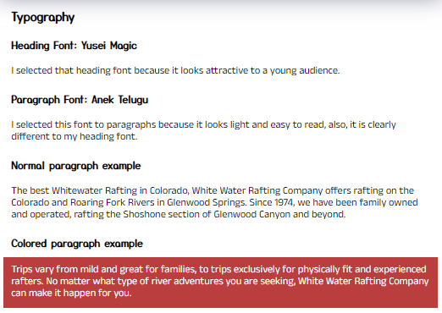

**Wireframe**

Large

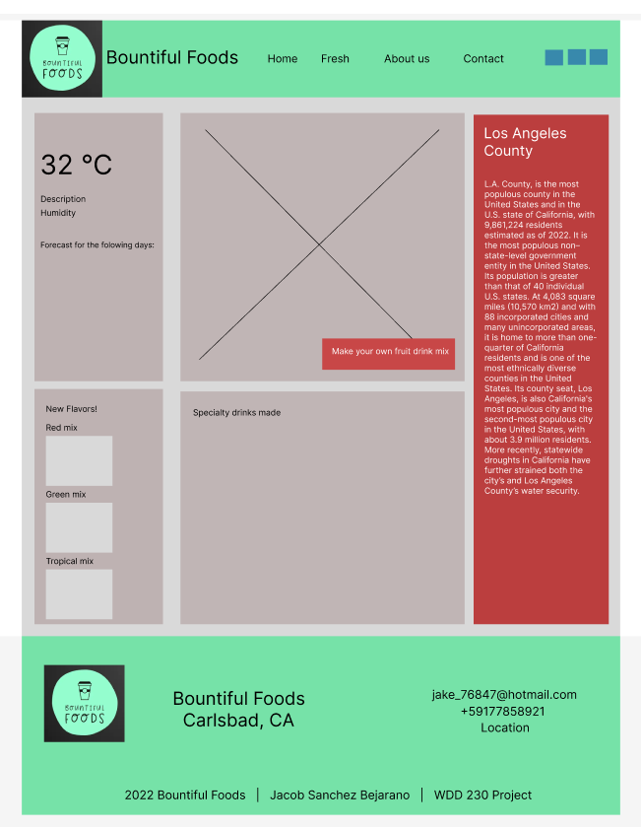

Medium

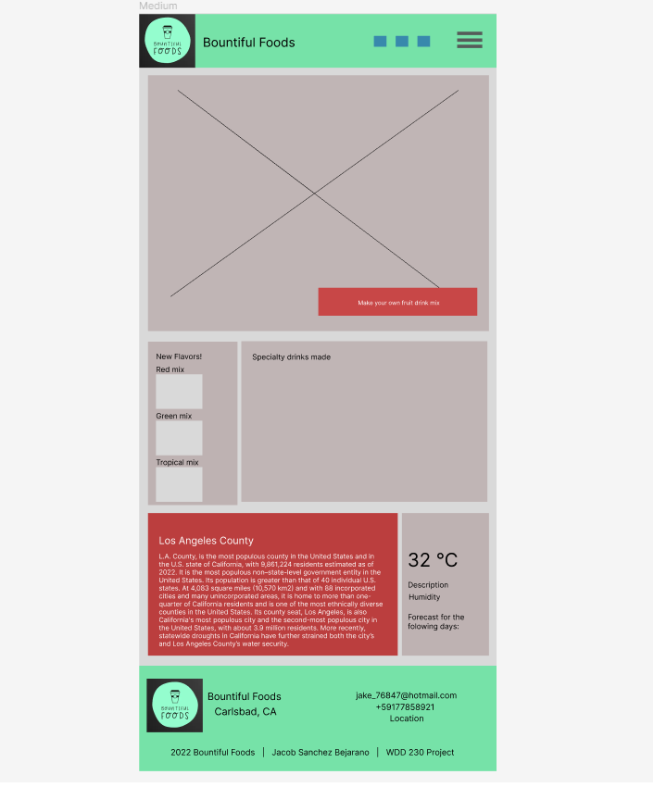

Small

